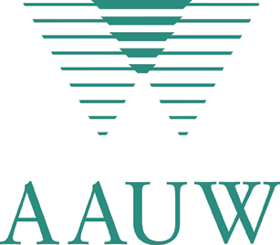

AAUW OF GEORGIA Board Meeting

Saturday October 19, 2013

AGENDA

9:00 – 9:30 | Registration and Refreshments  Distribute survey sheet  Introduction of AAUW Regional Representative Chardonnay Singleton, who will be working with us on Public Policy and Organizational matters.  Minutes Betty Slater  Report on National Convention: All conference attendees share their impressions.
College and University Relations: Betty Slater. Do we need a
new College-University Representative on the state level

Public policy update, delivered by Diana Witt, Chardonnay Singleton, and other GWC attendees.

BREAK

Budget review and any budget requests

Working policies and procedures and Bylaws review
Bea Piddock. Introduction of new Bylaws Chair Carrie Smith

State directory update Evelyn Merck

LUNCH

Membership update: Laurie Shaw

State and branch contributions update: Marlene Humphry

 | Cherokee Rose production and distribution. Diana Witt for Margaret Mathews. Details of organizational grant from national
Planning for 2014 Convention

We hope to end our board meeting by 3 PM

REGISTRATION

Name__ ____Branch Name ____________

Branch Office or Committee Chair____State Office_______________________________

Phone number (in case we need to reach you)__________________________________

E-mail____________________________________________________________

Student or Guest? Indicate College/University or Host _______________________

An array of sandwiches, including a vegetarian option, along with drinks and dessert, will be available for lunch.

Send registration with check made payable to Georgia AAUW in the amount of $15.00 (for registration and meal) by October 6 to:

Bea Piddock, Registrar
1914 Pine Bluff
Marietta, GA 30062
770-565-7583
bpiddock@earthlink.net

DIRECTIONS TO
Country Inn and Suites, 4500 Circle 75 Pkwy, Atlanta, GA.
This hotel is accessible from both 285 and 75. Directions are available on the hotel website.

Please remember you can be reimbursed for your mileage for this meeting.

